**Description of the Project**

**Software Used for the Project :** Eclipse IDE ,MySql Workbench.

**Aim of the Project :** Aim of the Project is to build a software for a sports store management where Buyers can buy the products for the shop and the shop Assistant/Employee can monitor the store .

**User Interface of the Project:** For the project ,I have used the default interface which is given by default in the jframe/GUI.

**Buyers Section :**

**First Login Frame**

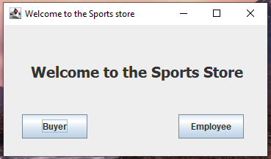

The Above image is the First login Frame .In this Page ,I have used a jframe title ,jLabel and the two buttons which are Buyer and Employee .If the user click on the button “Buyer” ,Then the Buyer information Frame will appear which is given below:

**Buyer Login Page**

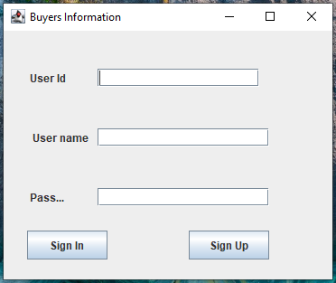

In this Page ,I have given three label and textfield where the buyer will give his/her id, name and password .if the buyer is new to the shop’s application then he/she will click the sign in button and his information will be entered into the shops database.

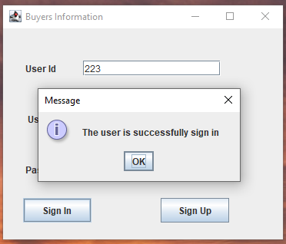

**N.B:** This message will be shown when a new buyer sign into the application

Again ,if a old buyer of the shop want to enter the shop then he/she will have to give his/her id and password ,if the id and password matches ,then a message of his name will show .the screenshot of the work of sign up button is given below:

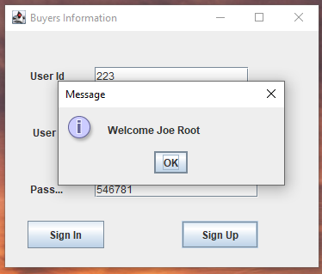

After this message ,the buyer will then enter into the page where the list of products is given ,from there he/she can take the information for buying anything from the shop .

**Product List page**

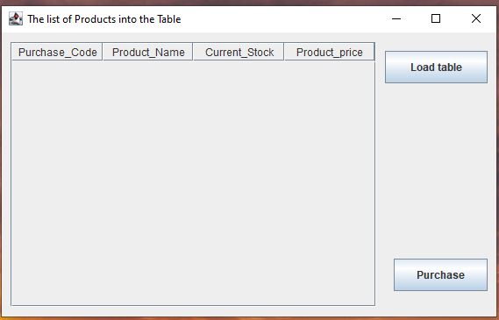

This is the list of product Page where there is a table and two buttons if the “Load table” is clicked then the list of products into the shop will be shown .

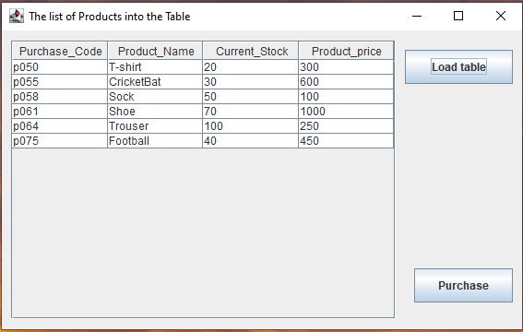

After seeing the information from here ,the buyer may want to go to buy something from the shop .So for buying anything from the shop ,the buyer have to click on the purchase button.

**Purchase Form Page**

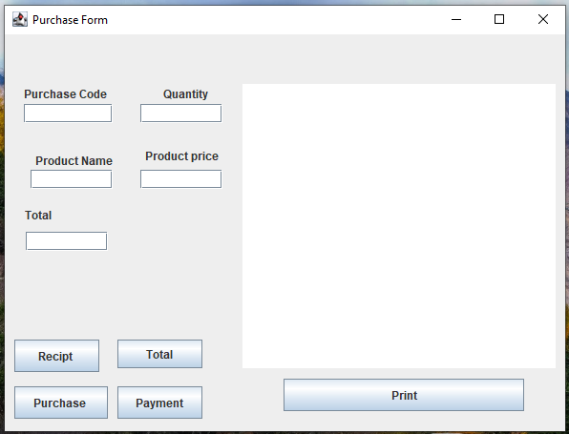

This is the purchase form from where the buyer can buy things from the shop .In this page ,there are five labels ,5 textfields ,5 buttons and a textarea where the receipt of the bill of the the buyer will be shown into the text area.

**Purchase Button:** When the button is clicked by the buyer ,then the information of the purchase will be entered into the shop’s database and a message will be shown to the buyer that the purchase is added.

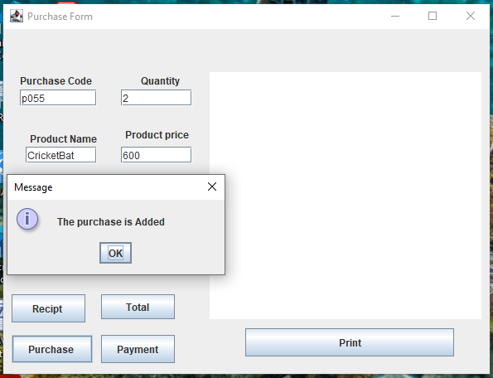

**Recipt Button:** If this button is clicked ,then the the bill products which the buyer buy will be shown into the textarea. The screenshot of the work of recipt button will be shown below:

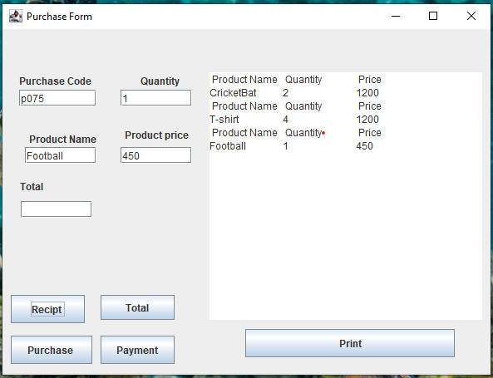

**Total Button:** When the total button is clicked ,then the total amount of the bill of the products the buyers buy is shown .

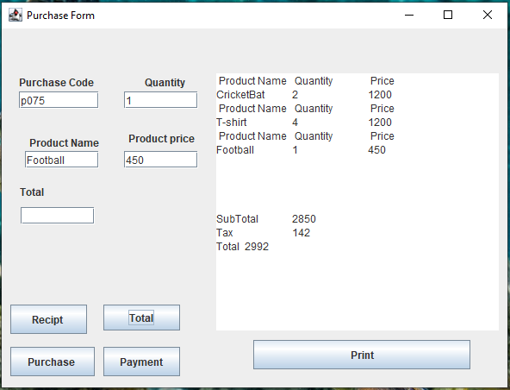

**Print Button:** If the print button is clicked ,then the bill will be printed .

After that the user will go for the payment of his bill .So when he Payment button is clicked the page given below will open up.

**Payment Page**

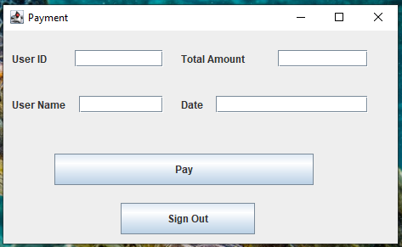

This is the Payment page of the application where the buyer will pay the bill. Here I used 4 textfields and 2 button .

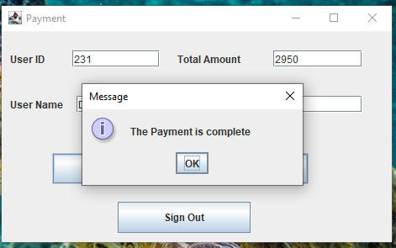

After that the buyer will sign out of the application using the sign out button .

**Employers Section:**

**First login Page:**



This is also the first page for the employees . When they click on the Button “Employee”, the following page is shown .

**Sign Up Page**

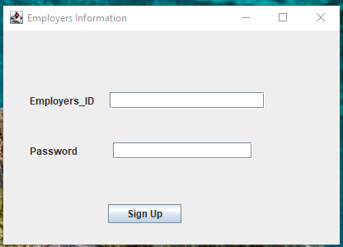

In this sign up page , I have given two textfields and 1 sign up button. In the textfields the employee will give his/her id and password. IF the id and password matches with his/her information into the database ,then his/her name will be shown with a welcome message.

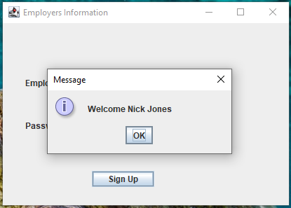

After Sign Up ,the employee details page will be shown.

**Employee Details Page**

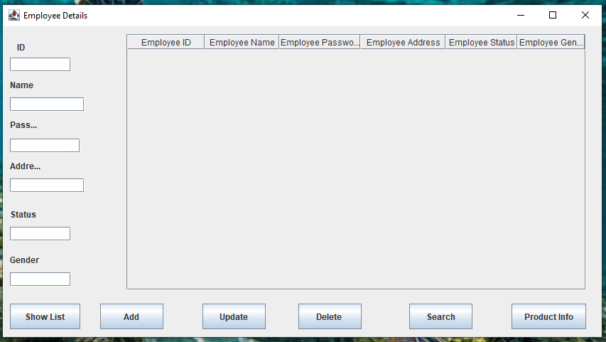

This is the employee details page where the Manager will monitor the list of details of the employees who work into the shop.

Here I have given ,Six textfields ,six buttons and one table where the list of the employees work into the shop will be shown.

**Show list Button:** When the manager click this button ,then the full list of employees working into the shop will be shown inside the table.

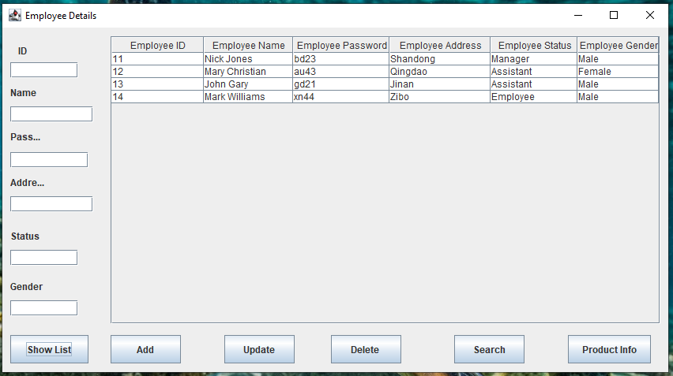

**Add Button:** IF a new employee have joined the shop ,then the manager will give his/her information into the textfields and click this button then a message will shown that the information is added into the shop database.

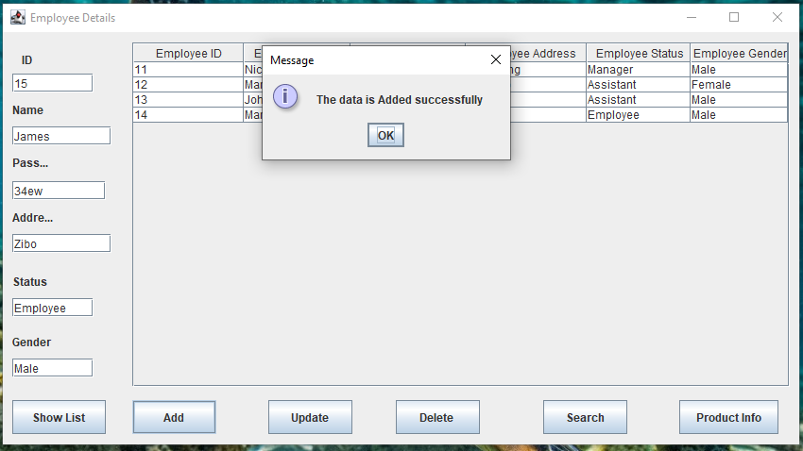

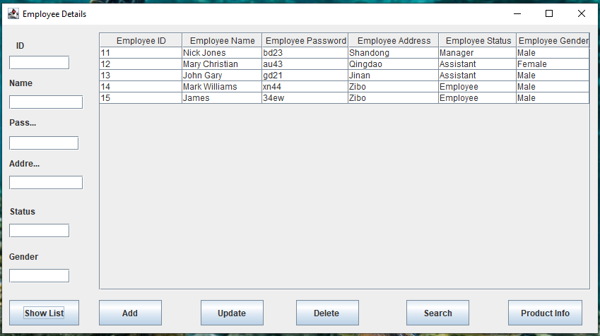

**Update Button:** IF the manager want to update information of any employee ,then he have to give the information into the text fields and clicked this button ,then a message will be shown and the employees information into the database will also update .

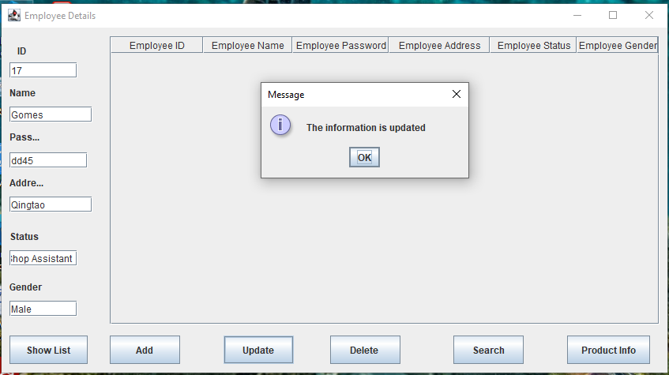

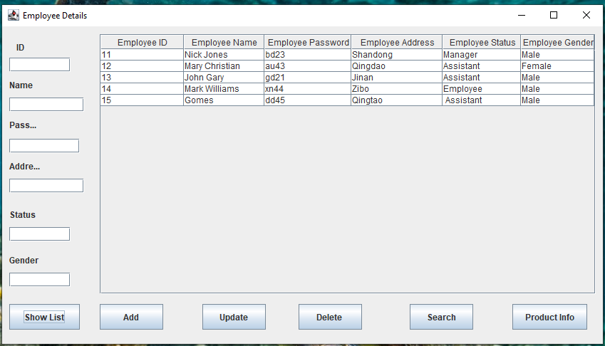

**Delete Button:** When any employee left the job and the manager have to delete the information then he have to give the id of the employer and click this button and the information will be deleted.

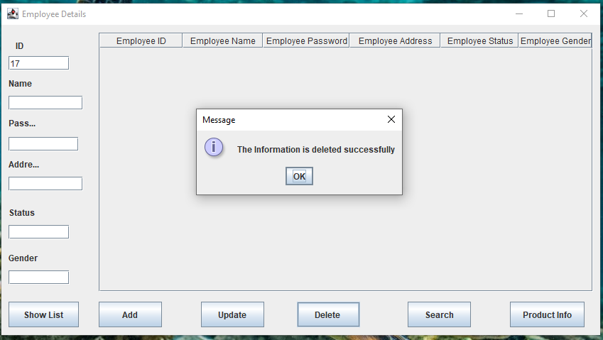

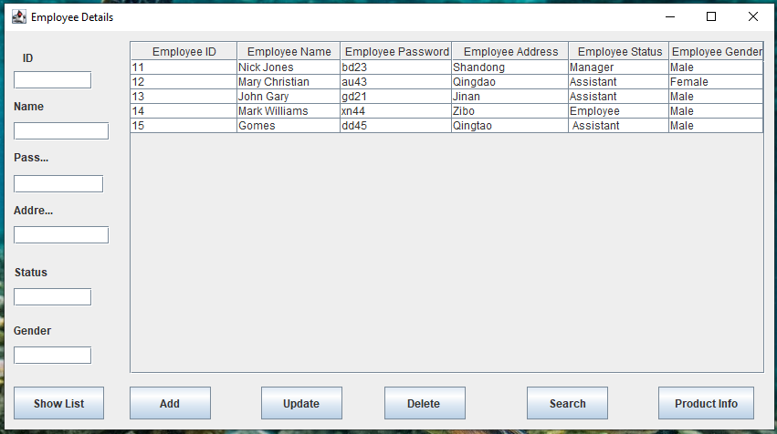

**Search Button**: IF the manager want to see information of an specified employee then he/have to enter that employers id and click on the search button and the information will be shown inside the table.

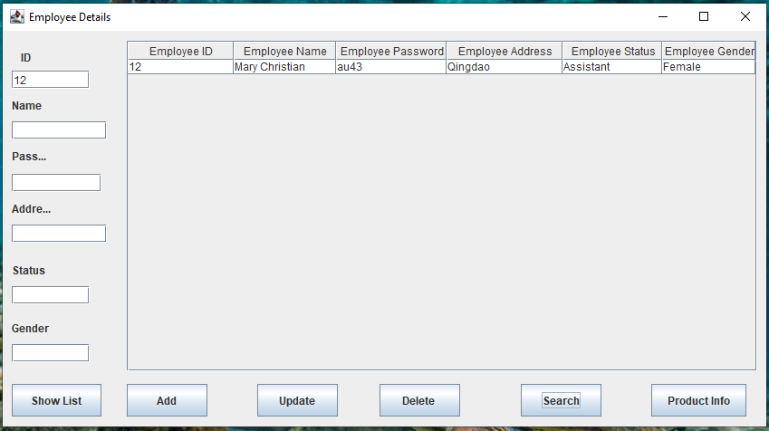

**Product Button:**  When the manager/Shop assistant want to see list of products inside the shop then he/she will click the button and the Product list page will appear .

**Shop Control Panel Page**

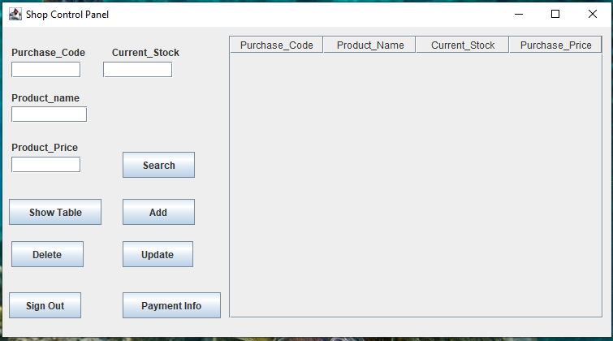

This is the shop control panel where the manager can see the list of products inside the shop.

In this page , there is four textfields with label Purchase_Code ,Product_name ,Current_Stock ,Product_Price and there is seven buttons .

**Show Table:** When this button is clicked then the list of the products will be shown into the table .

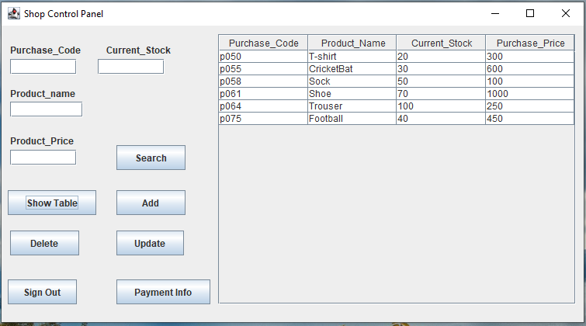

**Add button :** When the manager have to add product into the list then he/she have to enter the information into the textfield and click this button then information will be entered into the table and the database.

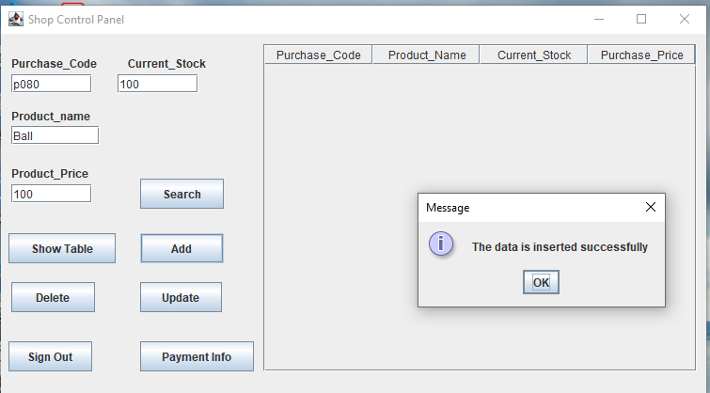

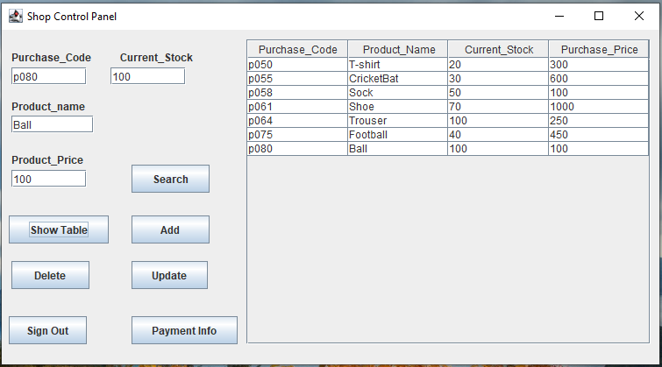

**Delete Button:** When the manager have to delete any information from the table then he/have to enter the Purchase_Code of the product and then click this button then the information will be deleted and a message will be shown.

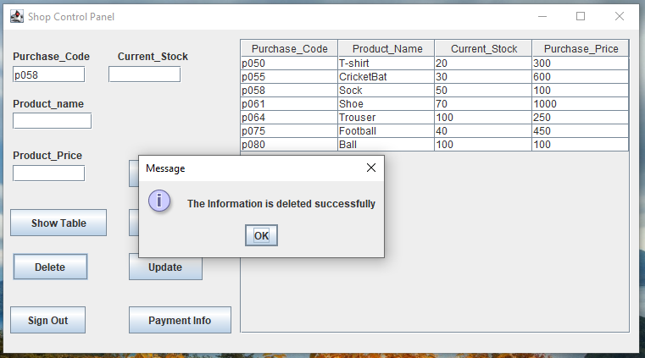

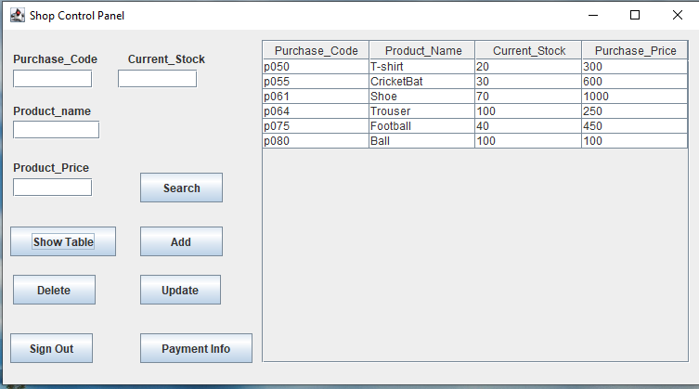

**Search Button:** When the manager/employee have to see the information about a specified product then he/she have to give the purchase code of the product and click this button then the specified information will be shown inside the table.

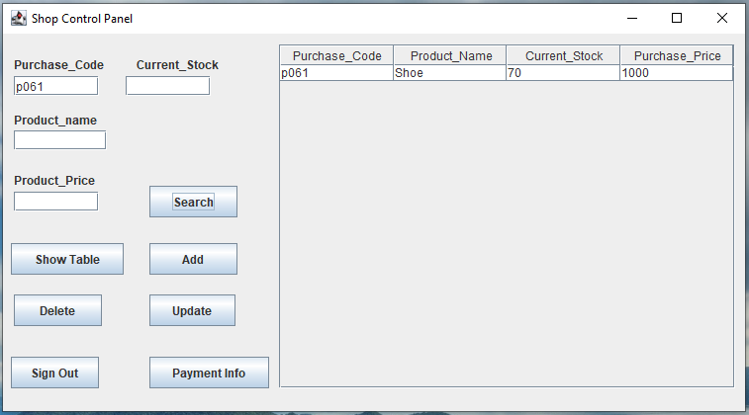

**Update Button:** When the manager have to update any information of a product then he/she have to enter the information which he want to update and click this button then the information will be updated.

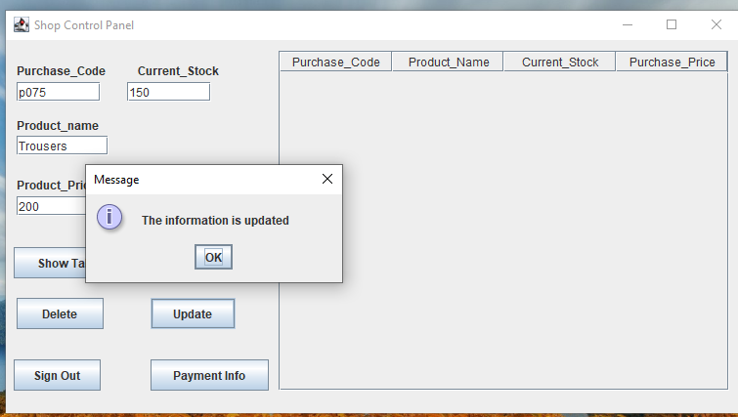

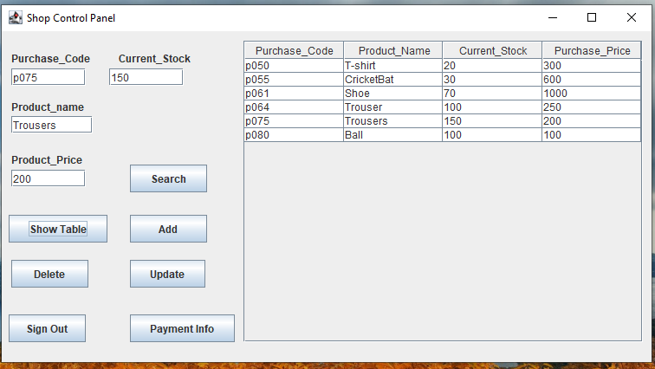

If the employee want to exit the application then he will click on the sign out button .when click on it ,it will show that if he/she want to exit the application or not.

Rather when he/she will click on the payment info button then the page below will appear.

**Payment Details:**

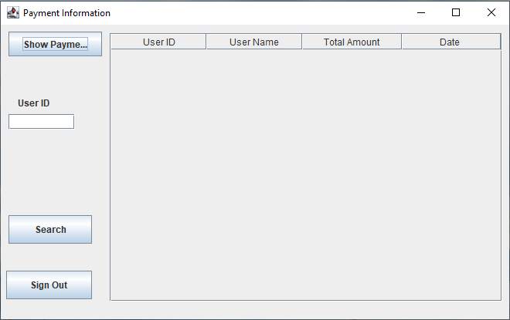

This is the Payment details page where the Manager/employee can see the payment details of the buyer. Here I have given three buttons ,one textfield and a table.

**Show Payment Button:** When this button is clicked ,then the payment information will appear inside the table.

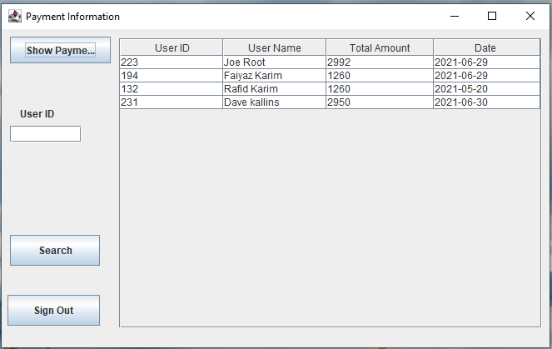

**Search Button:** if the manager/employee want to know information about an specified payment info then he/she have to enter the user id into the text field and click this button and the information will be shown into the table.

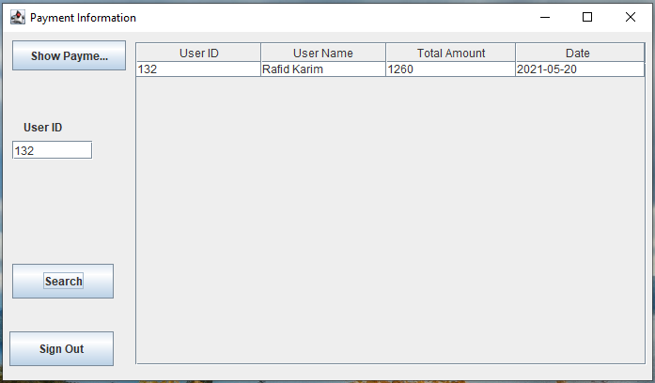

After that the Manager/employer will sign out of the application using the sign out using the sign out button in the page.